**FEEDBACK AMPLIFIER WITH CLOSED LOOP**

AIM:

Design a two-stage operational amplifier with the first stage as a differential amplifier with active load for a gain of 30V/V and the second stage as a CS Amplifier with a gain of 20V/V. Assume I SS =0.1mA, V GS =0.7V, V th =0.4V and consider suitable technology parameters values.

i) Compare the result with LTSPICE Simulation.

ii) Perform the transient analysis of the same.

APPARATUS REQUIRED:

LTSpice Software.

Circuit:

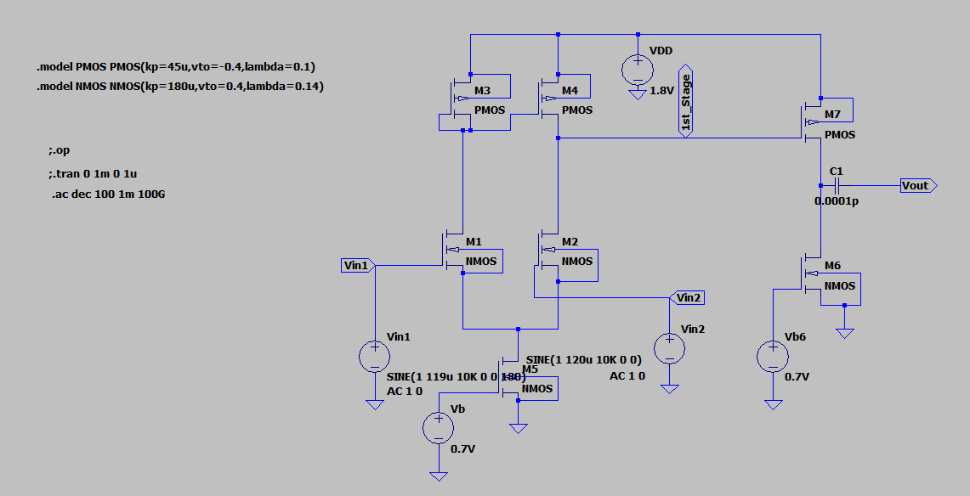

Output:

Vinput

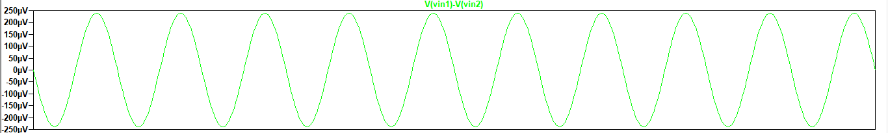

V(output)

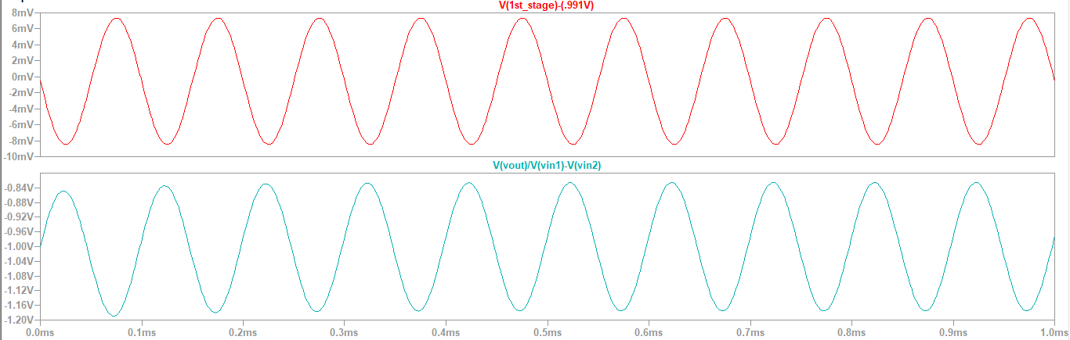

Transfer Function:

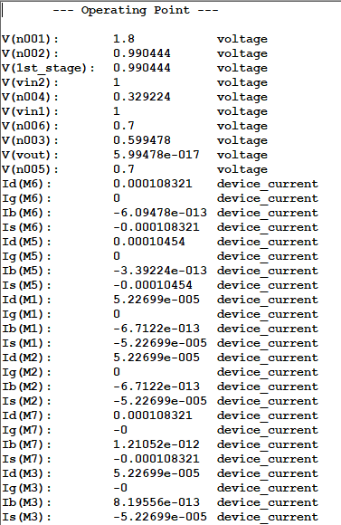

RESULT:

The circuit is implemented and the gain of 600 V/V is attained.